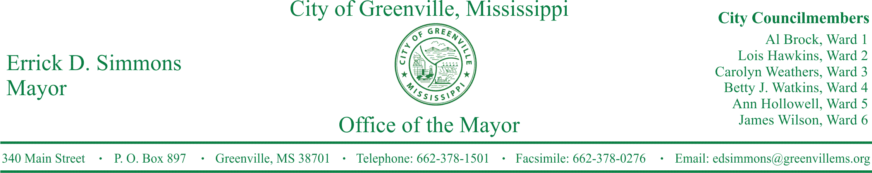
PRESS RELEASE
FOR IMMEDIATE RELEASE For more information contact:
Chief Delando Wilson
DWilson@greenvillems.org
662-822-7031

Greenville Police Department Raises Over $2,000 for Cpl. Derrick Couch
Greenville Police Department leads effort to raise money for Corporal Derrick Couch of the Clarksdale Police Department
GREENVILLE, Miss. (March 1, 2016) Today, Greenville Police Department sent a check to Cpl. Derrick Couch, a police officer with the Clarksdale Police Department. Cpl. Couch was shot February 13, 2016, responding to an armed robbery call.
STATEMENTS
Greenville Chief of Police Delando Wilson: “There was a tremendous outpour of support from the City of Greenville employees and the community. With those generous donations, we were able to raise $2,045 for Corporal Couch as he recovers from this terrible incident”
Mayor of Grenville Errick D. Simmons: “I applaud Chief Wilson for his leadership and every police officer, city employee, and citizen for their acts of kindness.”

###

