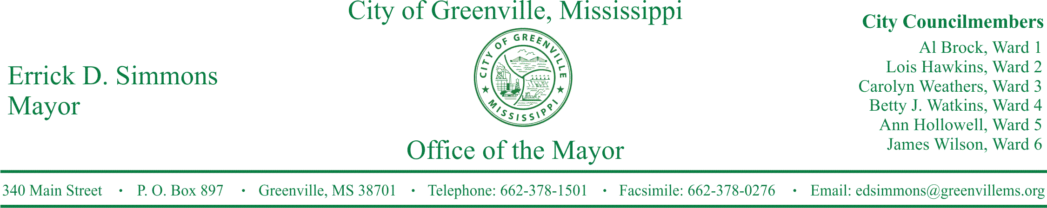
PRESS RELEASE
FOR IMMEDIATE RELEASE For more information contact:
Nikki Landrum
nlandrum@greenvillems.org
662-378-1534

Greenville launches 5th Annual City-Wide Internship Program
‘Go Greenville Internship Program’ now accepting applications from College juniors and seniors

GREENVILLE, Miss. (March 7, 2016) Now in its fifth year, the Go Greenville Internship Program offers college juniors and seniors who graduated from a high school in Greenville to intern with a Greenville business for ten weeks this summer.
While the main focus of the program is pairing college students with a host organization for their ten week internship, the Go Greenville program also has a professional development/service project component. The ultimate goal of the program is to stop the outward migration of Greenville’s college educated young people by enticing young people to return home to Greenville for employment opportunities.
The application deadline is April 22, 2016. Interested students may pick up an application at City Hall in the Mayor’s Office.
For more information, contact the Mayor’s Office, or 2016 Go Greenville Internship Coordinator Nikki Landrum at (662) 378-1534 or (662)347-3308 nlandrum@greenvillems.org.
###

