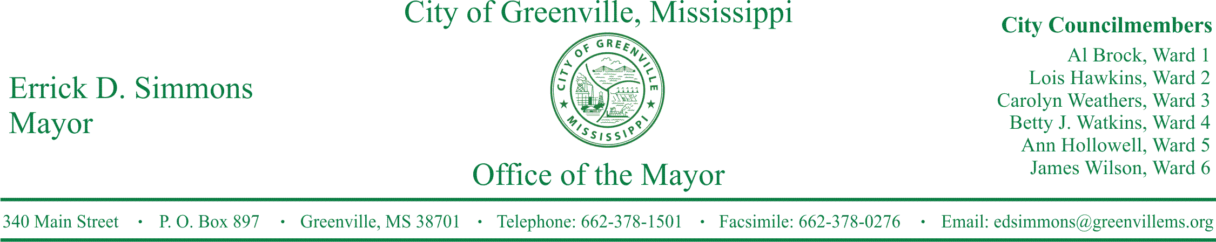
PRESS RELEASE
FOR IMMEDIATE RELEASE For more information contact:
Kenya L. Collins
kcollins@greenvillems.org
662-378-1501

Mid-Delta Airport Announces Record Enplanements
Mayor Simmons and Airport Director Lee Owen announces record enplanements at Greenville’s Airport.
GREENVILLE, Miss. (September 7, 2016) Today, Airport Director Lee Owen announces record enplanements at Greenville’s Mid-Delta Airport. The July enplanement numbers for Boutique Air were a new high of 470 enplanements. For three straight months Boutique Air has broken enplanement records for Mid-Delta Airport. Boutique started service at Mid-Delta Airport November of 2015. Boutique Air flies from Mid –Delta Airport to Nashville, Tennessee and to Dallas-Fort Worth, Texas.
Boutique Air Enplanement Numbers for Greenville’s Mid-Delta Airport

November 2015 145 enplanements
December 2015 276 enplanements
January 2016 260 enplanements
February 2016 371 enplanements
March 2016 343 enplanements
April 2016 373 enplanements
May 2016 387 enplanements
June 2016 457 enplanements
July 2016 470 enplanements

STATEMENTS
Mayor Errick D. Simmons
It brings me great joy and excitement that folks around the Delta and in the State are choosing Boutique Air to meet their air service needs. We have not seen record numbers like these since Delta Airlines. Great things are happening at Greenville Mid-Delta Airport. Fly Greenville. Fly Greenville-Delta Airport. Fly Boutique Air.

Shawn Simpson COO of Boutique Air
Boutique Air is delighted to see the continued traffic growth in Greenville. Since starting service in November 2015, Boutique Air has more than tripled the number of passengers flying in and out of the Mid Delta Regional Airport compared to the average over the preceding two years. Total passengers for the airport for the month of July reached 941. The connections to both Dallas and Nashville from the Mid Delta has proven to be very popular, with load factors reaching 76% in July. We are excited about the success and look forward to seeing the positive trends continue.
Airport Director Lee Owen
Woo hoo!!!! Another record month for boutique enplanements. This makes the third month in a row!! Good things are happening at the Greenville Mid-Delta Airport!!! 470 enplanements, the previous best was 457 last month. I have met and visited with people from Jackson, Madison, Ridgeland, Yazoo City, Greenwood, even from Starkville coming to Greenville for the great rates and free parking! These people have been a wide range of travelers. People going to see family, or to attend events, or on business trips. They have shared their experiences of flying with Boutique. Across the board it has been very pleasant. From the friendly pilots to the very helpful reservationists, to the check in counter personnel.

###

