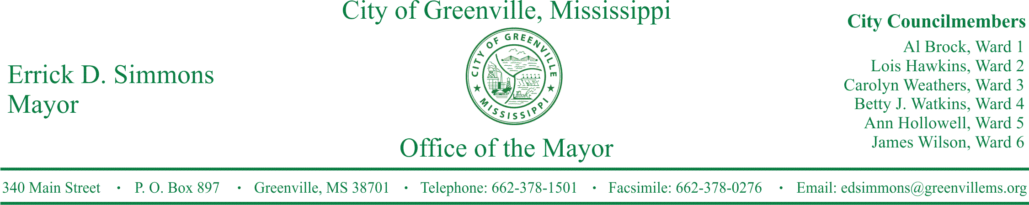
PRESS RELEASE
FOR IMMEDIATE RELEASE For more information contact:
Kenya L. Collins
KCollins@greenvillems.org
662-378-1501

Mayor’s Youth Council Announces “Gifts for Geriatrics”

GREENVILLE, Miss. (November 21, 2016) The City of Greenville Mayor’s Youth Council is announcing its first “Gifts for Geriatrics” project which will be held on Today, November 21, 2016. The Mayor’s Youth Council will visit Arbor Walk Healthcare Center located at 570 North Solomon Street in Greenville from 10 a.m. until 12 p.m. to take gifts of love, paint fingernails, comb hair, and play games with the elderly. For more information about the Mayor’s Youth Council and how you can support the council, contact Nikki Landrum at 662-378-1534 or NLandrum@grenvillems.org.
STATEMENTS
Mayor Errick D. Simmons Gifts for Geriatrics is just another way members of the Mayor’s Youth Council are rolling up their sleeves and contributing to our community. We want our youth to become invested in Greenville. I’m really proud of the great work our youth are doing.
Nikki Landrum, Program Coordinator “We should value all ages in our community, from the very young to the elderly. Developing stronger connections between these older adults and their community can have tremendous benefits for the young people. This is also a way to teach the students the importance of doing acts of service, and simply giving of their time. Visits to healthcare facilities teach us in subtle ways the frailty and temporary nature of life. They help us realize how thankful we should be for our present health and sound mind.
###

