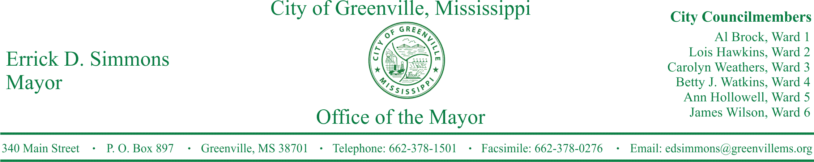
PRESS RELEASE
FOR IMMEDIATE RELEASE For more information contact:
Kenya L. Collins
KCollins@greenvillems.org
662-378-1501

Mayor Errick D. Simmons Announces Public Wireless Service At Stein Mart Square
Mayor Simmons announces public wireless service at Stein Mart Square with expansions planned soon.

GREENVILLE, Miss. (October 12, 2016) Today, Mayor Errick D. Simmons announced public wireless at Stein Mart Square. The city is supplying the bandwidth as a public service. It is about 20 MB of service. It can service most day to day use at the square. Mark DiBiase with Infinite Concepts developed the new system with very little equipment cost to the city as part of his IT support contract. There are also plans to expand the service into Shelben Park later this fall.

STATEMENTS
Errick D. Simmons, Mayor Wireless service in Stein Mart Square falls in line with our plan to bring Greenville into the technological advances of our time. Our next move is to provide Wi-Fi to Shelben Park. This is another great day for Greenville and our citizens.

Mark DiBiase, External IT Manager With the increased bandwidth available to the city through our knowledge of the market, we are able to provide a portion of it for patrons of city parks. It is just one more way that we are bringing new services to the city without having to incur substantial recurring costs.

###

