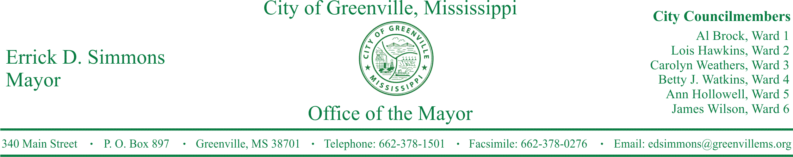
PRESS RELEASE
FOR IMMEDIATE RELEASE For more information contact:
Kenya L. Collins
KCollins@greenvillems.org
662-378-1501

WBAD in conjunction with Mayor Simmons Give Away 50 Turkeys to Local Families

GREENVILLE, Miss. (November 22, 2016) Today, Mayor Simmons announces a partnership with WBAD to giveaway 50 turkeys to local families for Thanksgiving. The turkeys will be given away to those calling into WBAD on 8:00 a.m. – 10:00 a.m. Wednesday, November 23, 2016. Winners can pick-up their turkeys from City Hall between 10:00 a.m. -11:00 a.m. Wednesday, November 23, 2016. The number for WBAD is 662-335-9264.

###

