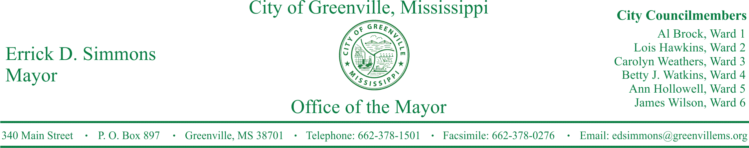
PRESS RELEASE
FOR IMMEDIATE RELEASE For more information contact:
Kenya L. Collins
kcollins@greenvillems.org
662-379-3543

Greenville, Mississippi, Named One Of The “Most Livable” Cities In America
U.S. Conference of Mayors Announces 2017 City Livability Award Winners at 85th Annual Meeting
GREENVILLE, Miss. (January 23, 2017) Mayor Errick D. Simmons and Greenville have been awarded an Outstanding Achievement Award at the 2017 City Livability Awards Program during The U.S. Conference of Mayors’ 85th Annual Meeting in Miami Beach. Greenville is one of five cities with populations of less than 100,000 to receive the award.
The award recognizes mayoral leadership in developing and implementing programs that improve the quality of life in America’s cities, focusing on the leadership, creativity, and innovation demonstrated by the mayors. This year’s winning cities were selected by former mayors from a pool of over 150 applicants.
This is the 38TH year in which cities have competed for the award, which is sponsored by the Conference of Mayors and Waste Management, Inc., the nation’s largest environmental solutions provider.
This year’s first place winners were Los Angeles Mayor Eric Garcetti for a local program focused on keeping city streets and alleys clean, as well as Hattiesburg, Mississippi Mayor Johnny L. DuPree for a local literacy initiative where young people are able to access free books through library lounges in local restaurants.
Greenville was honored for its Worship on the Water program, a nondenominational worship service that takes place at Schelben Park every fifth Sunday. Local members of the clergy preside over the festivities, which are always open to the public.
STATEMENT
Mayor Errick D. Simmons This award calls attention to the efforts of the citizens of Greenville to make the city more livable. Worship on the Water is a program that reaches across lines of race, class, and religion. When the common denominator of faith brings us all together in worship, we are truly One Greenville. On behalf of the City of Greenville, I extend my heartfelt thanks to the United States Conference of Mayors for this honor and my deepest congratulations to the other recipients, especially my fellow Mississippian, especially Mayor DuPree of Hattiesburg.
###

